KL03 - KL03 Display Activity type

Functionality

Activity types describe activities produced by a cost center. They are measured in units of time or quantity. This transaction code is used to the display the master data for activity type.
Scenario

This transaction is used to display an activity type master data.

Requirements
The activity type must be created.

Menu Path | Accounting → Controlling → Cost Center Accounting → Master Data → Activity Type → Individual Processing → KL03 - Display
Transaction Code | KL03

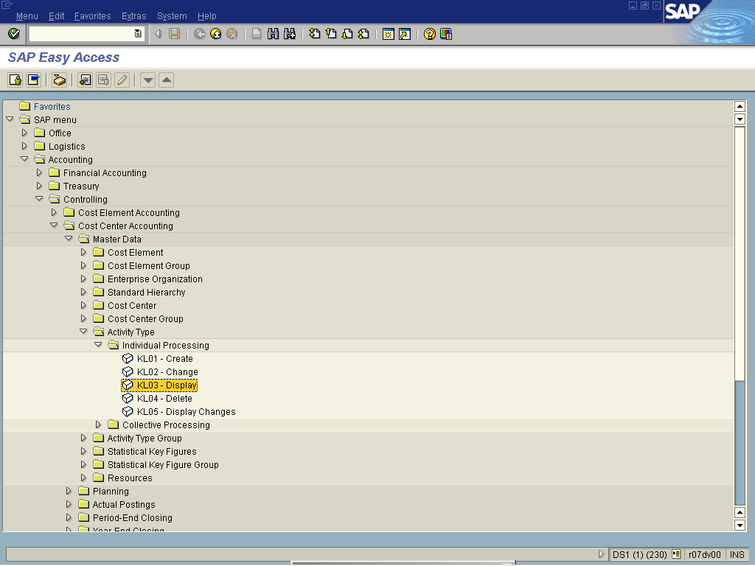

1. Double Click on KL03 - Display

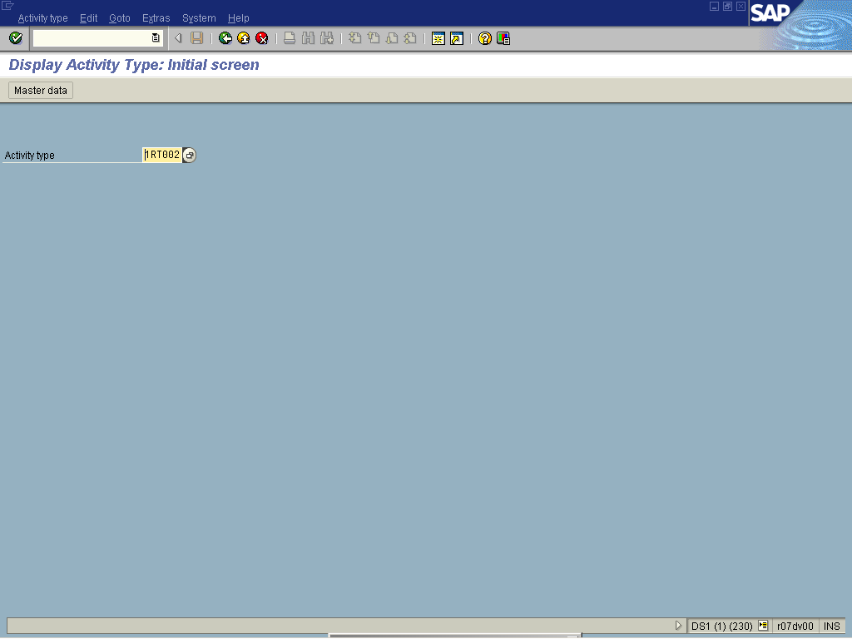

2. Update the following fields:

Field Name | Field Description | Values
Activity type | Activity types describe the activity produced by a cost center and are measured in units of time or quantity. | Example: 1RT002

3. Click Master data .

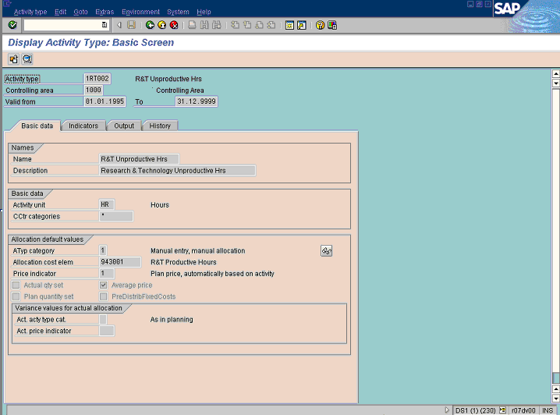
Note: This activity type is used for unproductive hours.

4. Click Back

